**Experiment No. 9: Depth First Search and Breath First Search**

**YASH MOHADIKAR**

**SE-03**

**07**

**Aim :** **Implementation of DFS and BFS traversal of graph**.

**Objective:**

1. Understand the Graph data structure and its basic operations.
2. Understand the method of representing a graph.
3. Understand the method of constructing the Graph ADT and defining its operations

**Theory:**

A graph is a collection of nodes or vertex, connected in pairs by lines referred as edges. A graph can be directed or undirected graph.

One method of traversing through nodes is depth first search. Here we traverse from starting node and proceeds from top to bottom. At a moment we reach a dead end from where the further movement is not possible and we backtrack and then proceed according to left right order. A stack is used to keep track of a visited node which helps in backtracking.

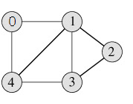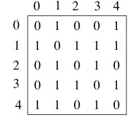

**DFS Traversal –0 1 2 3 4**

**Algorithm**

Algorithm: DFS_LL(V)

Input: V is a starting vertex

Output : A list VISIT giving order of visited vertices during traversal.

Description: linked structure of graph with gptr as pointer

1. if gptr = NULL then

print “Graph is empty” exit

1. u=v
2. OPEN.PUSH(u)
3. while OPEN.TOP !=NULL do

u=OPEN.POP()

if search(VISIT,u) = FALSE then

INSERT_END(VISIT,u)

Ptr = gptr(u)

While ptr.LINK != NULL do

Vptr = ptr.LINK

OPEN.PUSH(vptr.LABEL)

End while

End if

End while

1. Return VISIT
2. Stop

**BFS Traversal**

 

**BFS Traversal – 0 1 4 2 3**

**Algorithm**

Algorithm: DFS()

i=0

count=1

visited[i]=1

print("Visited vertex i")

repeat this till queue is empty or all nodes visited

repeat this for all nodes from first till last

if(g[i][j]!=0&&visited[j]!=1)

{

push(j)

}

i=pop()

print("Visited vertex i")

visited[i]=1

count++

Algorithm: BFS()

i=0

count=1

visited[i]=1

print("Visited vertex i")

repeat this till queue is empty or all nodes visited

repeat this for all nodes from first till last

if(g[i][j]!=0&&visited[j]!=1)

{

enqueue(j)

}

i=dequeue()

print("Visited vertex i")

visited[i]=1

count++

**Code:**

#include <stdio.h>

#include <stdlib.h>

struct node {

int data;

struct node *leftChild, *rightChild;

};

struct node *root = NULL;

struct node *newNode(int item){

struct node *temp = (struct node *)malloc(sizeof(struct node));

temp->data = item;

temp->leftChild = temp->rightChild = NULL;

return temp;

}

void insert(int data){

struct node *tempNode = (struct node*) malloc(sizeof(struct node));

struct node *current;

struct node *parent;

tempNode->data = data;

tempNode->leftChild = NULL;

tempNode->rightChild = NULL;

//if tree is empty

if(root == NULL) {

root = tempNode;

} else {

current = root;

parent = NULL;

while(1) {

parent = current;

//go to left of the tree

if(data < parent->data) {

current = current->leftChild;

//insert to the left

if(current == NULL) {

parent->leftChild = tempNode;

return;

}

}//go to right of the tree

else {

current = current->rightChild;

//insert to the right

if(current == NULL) {

parent->rightChild = tempNode;

return;

}

}

}

}

}

struct node* search(int data){

struct node *current = root;

printf("\nVisiting elements: ");

while(current->data != data) {

if(current != NULL) {

printf("%d ",current->data);

//go to left tree

if(current->data > data) {

current = current->leftChild;

}//else go to right tree

else {

current = current->rightChild;

}

//not found

if(current == NULL) {

return NULL;

}

}

}

return current;

}

void printTree(struct node* Node){

if(Node == NULL)

return;

printTree(Node->leftChild);

printf(" --%d", Node->data);

printTree(Node->rightChild);

}

int main(){

insert(10);

insert(14);

insert(19);

insert(26);

insert(27);

insert(31);

insert(33);

insert(35);

insert(42);

insert(44);

printf("Insertion done\n");

printTree(root);

struct node* k;

k = search(35);

if(k != NULL)

printf("\nElement %d found", k->data);

else

printf("\nElement not found");

return 0;

}

**Output**:

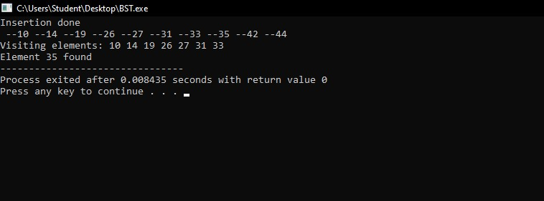

**Conclusion:** Both BFS and DFS are graph traversal algorithms. The most significant difference between the two is that the BFS algorithm uses a Queue to find the shortest path, while the DFS algorithm uses a Stack to find the shortest path.